

SCHOOL OF COMPUTER SCIENCE AND ENGINEERING

**BACHEL0R OF COMPUTER SCIENCE AND ENGINEERING**

“INTERNET PROGRAMMING LABORATORY”

COURSE CODE: CSE326

**TOPIC:**

***LEARNING SYSTEM***

***Learning System***

A **learning system** is essentially a collection of artefacts that are brought together in an appropriate way, in order to create an environment that will facilitate various types of **learning** process.

**Learning system**s can take a variety of different forms - for example, a book, a mobile form, a computer, an online forum, a school and a university. Most **learning system**s will provide various types of **learning** resource and descriptions of procedures for using these to achieve particular **learning** outcomes. They will also embed various strategies for assessing the levels and quality of the achievement of their users.

Pedagogy, most commonly understood as the approach to teaching, refers to the theory and practice of learning, and how this process influences, and is influenced by, the social, political and psychological development of learners

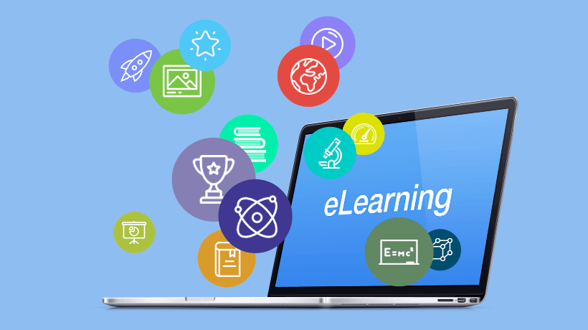

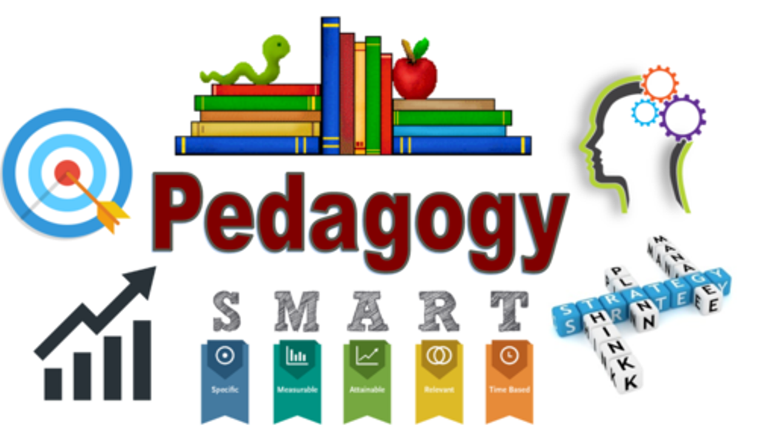

Learning can be done through various modes like books,e-learning,teachers etc.

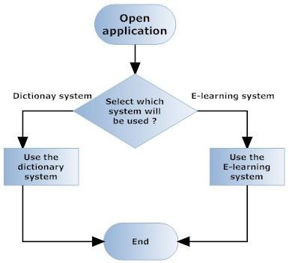

***Flow chart of learning system-***

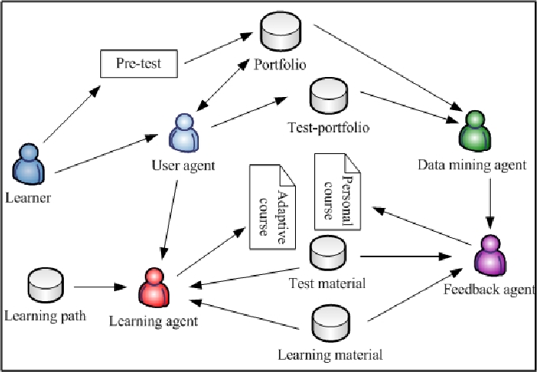

***Description of project:-***

In this project we had made a webpage of Learning System.

We have included different types of learning methods like books, teacher, e-learning.

In this webpage we have added videos , images , test, subjects ,topics, feedback, about us, contact us etc.

This webpage help the learner to learn new things through various modes of learning***.***

Learners will have access to millions or billions of knowledge modules. Some will be Web pages with simple text and graphics

***Conclusion***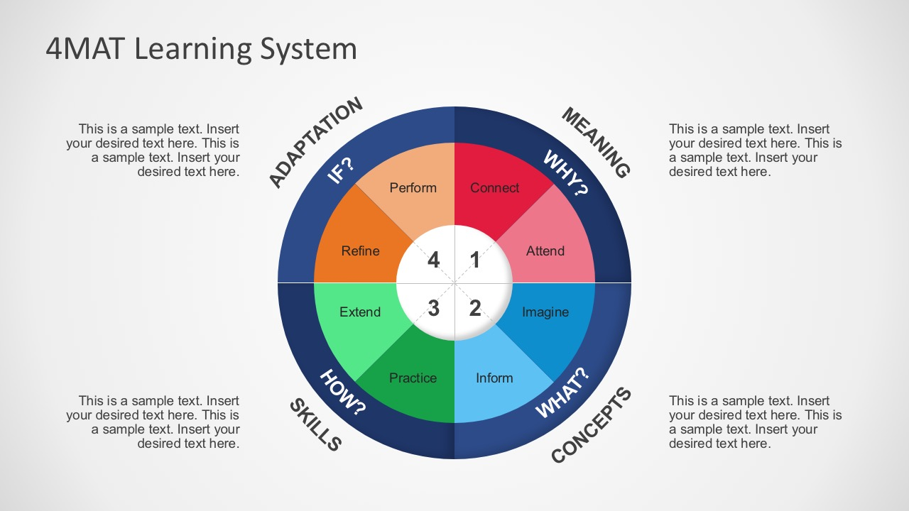

 It is part of a redefinition of how we as a species transmit knowledge, skills, and values to younger generations of workers and students.

Our webpage allow a learner to learn and test their knowledge and contact us if any query and also give us valuable feedback.

Through this webpage learner can learn new things through various models.

The quality of education has improved by online courses and even it has become easy for students to refer the content as per their leisure. In the era of digitalization the scope of online education increase even more and will be beneficial for students, professionals and also institutions.

From the above discussion we conclude that learning through ict or any other innovation style is benefitial.In this time mostly students prefer online learning which give better understanding ,test yourself etc.

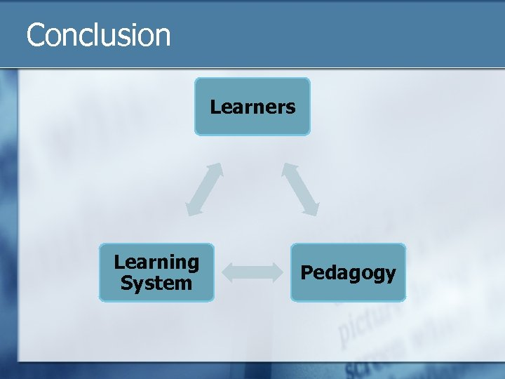

**Reference:**

[www.w3schools.com](http://www.w3schools.com)

Some videos and images were taken from internet and text is taken from Wikipedia.

***SUBMITTED BY:***

***NAME REGISTRATION NO. ROLL NO.***

Arijit Singh 11912269 22

Lovepreet Singh 11912259 23s

Shubham Mishra 11911784 24

**SUBMITTED TO:**

Mr. Moin Hasan

Professor, Lovely Professional University